**The presence of *BRCA1* mRNA expression in breast cancer patients and personalized therapy strategies**

# Introduction

The latest global statistics on cancer prevalence indicate that around 2.26 million new cases of breast cancer were reported in 2020, making it the primary cause of cancer-related deaths among women on a global scale (Wilkinson & Gathani, 2022). Early detection of breast cancer is associated with a higher chance of cure, underscoring the importance of developing new treatments (Burguin et al., 2021). *BRCA1* is a vital tumor suppressor gene involved in DNA repair, cell cycle regulation, transcription, and apoptosis to maintain genomic stability (Figure 1) (Silver & Livingston, 2012; Yoshida & Miki, 2004). *BRCA1* deficiency leads to impaired DNA repair and increased genomic instability in cells, elevating the risk of developing breast cancer (Takaoka & Miki, 2018). In this study, the gene expression of two patients was examined, with a specific emphasis on personalized therapy according to the levels of *BRCA1* mRNA expression.

In order to evaluate *BRCA1* expression, the procedure involved the extraction of total cellular RNA from two patients’ breast cancer cells, subsequent cDNA synthesis, and then the use of RT-PCR for *BRCA1* and *ACTB* analysis.

**Figure 1.** *BRCA1* occupies a central position in various interconnected cellular pathways, engaging with multiple intermediary proteins within these pathways to support genomic and cellular stability. (Mylavarapu et al., 2018)

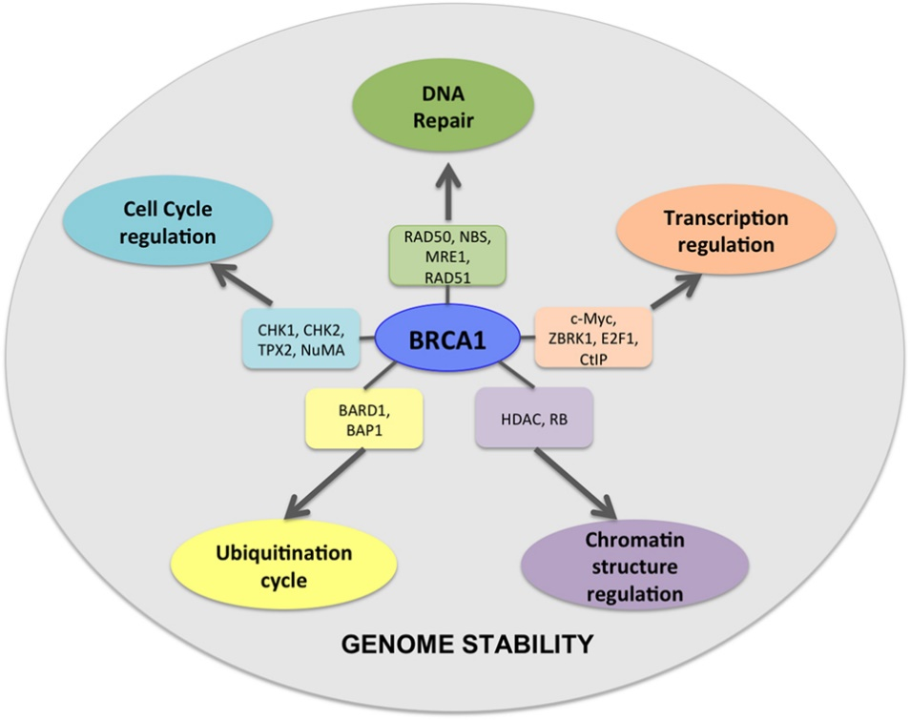

# Results

## RNA samples qualitative and quantitative analysis

An agarose gel electrophoresis was conducted to examine the purified RNA samples extracted from two pateints’ cell pellets of breast cancer cells. A “HyperLadder 1 kb” (MeridianBioscience) was used for this purpose (Meridian, 2023). The electrophoresis has performed as expected as the required bands (18S and 28S) were observed (Figure 2: Patient 1, Patient 2) (Copois et al., 2007). The RNA quality was good as no degradation was observed (Figure 2).

**Patient 2**

**1KB**

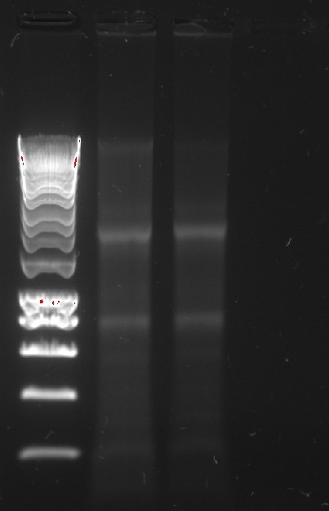

**1KB** **HL**

**Patient 1**

**28S**

**18S**

**Figure 2.** RNA qualitative analysis on agarose gel. HypperLadder (HL) of 1 KB is used as a weight molecular marker. Patient 1 is showing Patient 1 RNA and Patient 2 is showing Patient 2 RNA.

A quantitative analysis was conducted to synthesize an equivalent quantity of cDNA. The RNA quantitative analysis was performed using a Nanodrop UV-spectrophotometer and the results showed concentrations of 125.0 ng/μL for Patient 1 and 81.8 ng/μL for Patient 2 (Table 1) (Dwiyitno et al., 2018). The RNA displayed no signs of organic contamination, evident in the high 260/280 ratio, and there was no indication of contamination by other chemicals, as indicated by the 1.60 and 1.65 ratios of 260/230 (Fleige & Pfaffl, 2006). There was no evidence of protein contamination and perhaps minimal traces of contaminants from other sources, affirming the effective isolation of RNA with the use of this kit.

**Table 1.** **RNA concentrations extracted from two patient samples.** Values of 2.09 and 2.08 of 260/280 ratio show no signs of organic contamination. Values of 1.60 and 1.65 of 260/230 ratio show no signs of contamination by other chemicals.

|  |  |  |  |
| --- | --- | --- | --- |
|  | **Concentration (ng/μL)** | **260/280** | **260/230** |
| **Patient 1** | 125.0 | 2.09 | 1.60 |
| **Patient 2** | 81.8 | 2.08 | 1.65 |

## RT-PCR of mRNA for *BRCA1* (test) and beta actin *(ACTB)* (control)

RT-PCR was conducted to assess the expression levels of *BRCA1* and *ACTB* actin in both patients. RT-PCR was performed using One-Step RT-PCR Kit (Meridian Bioscience) and the PCR products were loaded in a 1.5% w/v agarose gel (Wagner, 2013). The results from the agarose gel electrophoresis are shown on the figure below (Figure 3). Lane 3 and 4 showed two distinct bands at size 111 bp for both patients. The observed bands represent the expression of the *ACTB* gene in both patients, functioning as a positive control. This confirms the success of the RT-PCR procedure, indicating the effectiveness of both RNA extraction and cDNA synthesis. Dionized water was used as a negative control in Lanes 5 and 6, and the absence of bands indicates that the samples were free from contamination. Nevertheless, *BRCA1* mRNA expression was evident only in Patient 1 (Lane 1), with no indication of *BRCA1* mRNA expression observed for Patient 2 (Lane 2). However, it is important to highlight that the lack of mRNA expression does not necessarily signify a loss of the *BRCA1* genomic locus, as the loss of expression could be connected to a variety of mutations (Press et al., 2008; Russell et al., 2000; Thompson et al., 1995). A slight smear was observed in Lane 2, whereas the negative control (water) shows no band or smear. This suggests potential mRNA degradation or minimal non-specific contamination at a low level.

In summary, the results suggest that Patient 1 exhibits *BRCA1* expression, while Patient 2 lacks *BRCA1* expression at the mRNA level.

**111 bp**

**100 bp**

**133 bp**

**200 bp**

**500 bp**

**1013 bp**

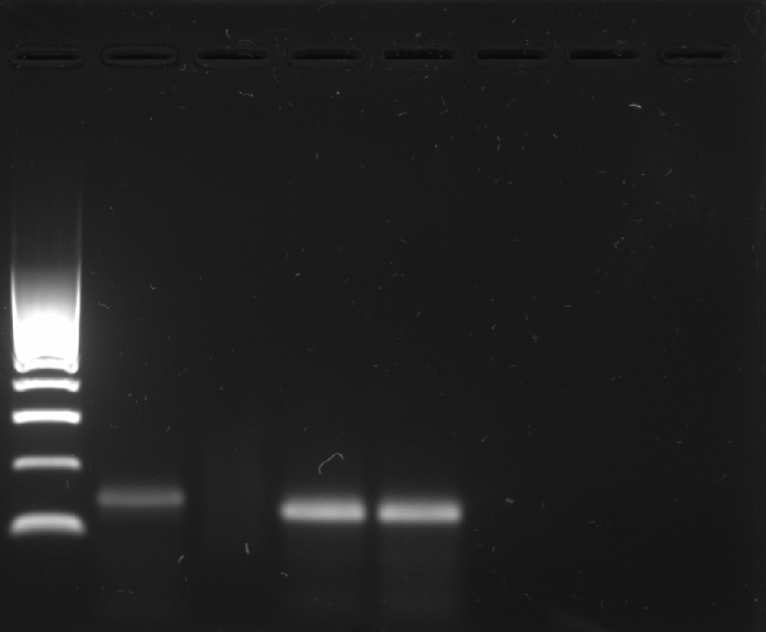

**HL**

**1**

**2**

**3**

**4**

**5**

**6**

**7**

**Figure 3.** RT-PCR results for BRCA1, ACTB (actin) and water as negative control. HypperLadder (HL) of 100bp, Lane 1: BRCA1 expression for Patient 1 (P1), Lane 2: BRCA1 expression for Patient 2 (P2), Lane 3: ACTIN for P1 sample, Lane 4: ACTIN for P2 sample, Lane 5: water control for BRCA1, Lane 6: water control for ACTIN.

# Interpretation of results

Detecting mRNA levels via RT-PCR faces a notable issue with DNA contamination, resulting in erroneously elevated mRNA concentrations (Añez-Lingerfelt et al., 2009). Therefore, the selected primers have crucial role for the efficacy of the analysis. The PCR primers used for the amplification of *BRCA1* and *ACTIN* in the RT-PCR can specifically detect only cDNA and mRNA, without binding to any genomic DNA sequence. These primers are thoroughly designed and yield precise outcomes in *BRCA1* research. In recent research applications with these primers, numerous potential actionable targets were successfully identified, providing novel insights on treating esophageal squamous cell carcinoma (ESCC) (Yan et al., 2019). Due to the existence of two types, *BRCA1* and *BRCA2*, one might infer that the gene expression originates from *BRCA2*, assuming that the same primer is binding to different *BRCA*. However, this scenario is not feasible as the primers are explicitly designed to bind to *BRCA1*. The single-stranded nature of RNA and the double-stranded structure of DNA result in RNA being a smaller molecule. Consequently, it moves faster through the gel, enabling the simultaneous detection of both RNA and DNA (Figure.2). The observed size of the *ACTB* (actin) (Figure 3) was 111 bp, suggesting that this actin originates from cDNA or mRNA rather than genomic DNA, which would have a size of 220 bp. In Step 8 of the RNA extraction lab protocol, the addition of reconstituted DNase I to break down any pre-existing DNA in the mixture has guaranteed the absence of DNA contamination, thereby ensuring the efficacy of the analysis. Identifying suitable genes for normalizing real-time RT-PCR data in breast cancer is crucial (Lyng et al., 2008). While beta-actin (*ACTB*) is commonly used, optimal results often stem from combining housekeeping genes (Wang et al., 2015). Notably, 18S rRNA-*ACTB* serves as the best reference gene combination across all cell lines; *ACTB-GAPDH* is optimal for basal breast cancer cell lines, and *HSPCB-ACTB* is most effective for ER+ breast cancer cells (Liu et al., 2015). Hence, incorporating an additional control gene would enhance the current analysis. A high concentration of dNTPs (10mM) was employed, and their quality is vital for the analysis (Mohsen et al., 2019). However, If these dNTPs were expired or defective in any way, it could impede the RT-PCR reaction from occurring. Negative RNA isolation controls are particularly valuable when the focus is on the quality of the isolated RNA for downstream molecular biology applications. However, water as negative control is widely used and effective.

Regarding the RT-PCR analysis and the accuracy of the observed results, it might be inferred that the technique was not performed correctly. However, if this was the case, the size of the *BRCA1* gene would deviate from the expected 133bp, or it would appear at a temperature different from the anticipated (45°C). The procedure was following standard One-Step RT-PCR protocol parameters (NEB, 2023). Furthermore, there is a risk of loop formation in RT-PCR analysis. This occurs if there is primer contamination, unappropriate negative controls or inadequate reaction conditions (Peters et al., 2004). Therefore, it could cause primer-dimer formation, false-positive results, or non-specific amplification (Peters et al., 2004). However, no ambiguous PCR results below the targeted sequence (hairpins) were observed (Figure 3). The results showed that only Patient 1 had *BRCA1* gene expression (Figure 3). Considering the possibility that the PCR have failed for Patient 2, it is important to note that if such failure occurred, it should have affected Patient 1 as well (actin expression for both patients). Furthermore, no difference between the two patients was observed (Figure 2), therefore no degradation of RNA samples. In particular, if mRNA levels are too low, RT-PCR might not be able to detect the existing gene expression. However, the concentrations of the RNA samples and their purity were examined (Table 1) and no contamination was observed, neither poor PCR conditions. Additionally, an agarose gel electrophoresis was conducted (Figure 2), to visualize the integrity and size distribution of the RNA samples.

As observed Patient 1 exhibits *BRCA1* gene expression (Figure 3). However, there is a chance that the observed band reflects solely nuclear mRNA and not the corresponding protein expression. It is highly probable that if mRNA synthesis occurs, protein synthesis follows, making exclusive mRNA expression without protein synthesis unlikely (Guo et al., 2008). As Patient 1 only expresses *BRCA1*, one might assume that this expression originates from genomic DNA. However, if that was the case, the observed band would be at the size of 4374bp, not the observed size of 133bp (cDNA). In the context of *BRCA1* a mutation on one copy of chromosome 17 may not completely eliminate the gene's function (Narod & Salmena, 2011). The other copy of the gene on the non-mutated chromosome can still contribute to DNA repair mechanisms. However, if a patient has breast cancer, both alleles will be inactive causing loss of the DNA repair mechanism (Godet & Gilkes, 2017). Therefore, such mutation is not the case of patient one. Patient 1 might possess a protein-level mutation (non-functional protein) as suggested by the findings indicating active transcription of the *BRCA1* gene. RNA interference (RNAi) and microRNA (miRNA) mechanisms, which operate at the post-transcriptional level, can indirectly impact *BRCA1* protein levels by regulating mRNA levels (Garcia et al., 2011). While RNAi and miRNA mechanisms primarily affect the synthesis of *BRCA1*, reduced protein synthesis could indirectly impact the pool of *BRCA1* available for ubiquitination and subsequent degradation (Winter et al., 2007). Consequently, the instability ofBRCA1 protein may be a potential factor contributing to breast cancer in Patient 1.

Patient 2 does not express *BRCA1* (Figure 3). However, the analysis solely focused on exons 6 and 7, suggesting the possibility of their loss rather than the entire *BRCA1* gene. Nevertheless, these specific exons are being used by all variants of *BRCA*. Therefore, the loss of the exons would result in the entire *BRCA* being lost as well. The suggestion for the lack of *BRCA1* expression in this patient is chromosomal abnormality-gene deleted or silenced at genomic level. Methylation of the *BRCA1* gene results in reduced *BRCA1* expression, which is followed by epigenetic silencing (transcriptional inactivation of *BRCA1*) and contributing to the development of breast cancer (Birgisdottir et al., 2006; Catteau & Morris, 2002; Kim et al., 2016; Lips et al., 2013; Rice et al., 2000). *BRCA1* gene methylation status is found to be negatively correlated with mRNA expression (Li et al., 2015; Rice et al., 1998). Furthermore, methylation can precede malignancy (aggressive cell growth) (Blecua et al., 2020). In the instance of Patient 2, it is plausible that epigenetic silencing and methylation have led to the absence of *BRCA1* gene expression.

RT-PCR specifically indicates mRNA levels and does not provide information about transcription levels or mRNA stability (Bustin, 2002). The RNA levels may not accurately represent the amount of protein generated by the cell, as regulatory processes often take place post-transcriptionally (Gygi et al., 1999). Consequently, RT-PCR data does not convey insights into protein activity or potential mutations in the target gene (Bustin, 2002). ELISA is a method that allows for the specific and quantitative measurement of BRCA1 protein expression (Crowther, 2008). However, it does not provide information about the functional state or activity of the protein (Crowther, 2008). Immunohistochemistry (IHC) is commonly used to detect and visualize protein levels in tissues (Duraiyan et al., 2012). There is evidence indicating that it possesses a high sensitivity in identifying patterns of protein expression, as well as in identifying potential therapeutic targets and diagnosing diseases (Galizia et al., 2010; Teixeira & Dos Reis, 2020). In this context, RT-PCR should be combined with other analyses, such as IHC and biochemical assays (ELISA). Functional and structural assays would be helpful too, as they aim to assess the impact of *BRCA1* expression or mutations on cellular processes related to its known functions (DNA repair etc) (Carvalho et al., 2007; Lee et al., 2010). Furthermore, DNA sequencing could be applied in order to research possible mutations in the *BRCA1* gene, which are not visible with the previous techniques (Costa et al., 2013). Study shows that women under 35 years old often experience a high occurrence of reduced nuclear *BRCA1* expression, potentially contributing to distinct tumor biology compared to older women (Lee, 2002). Therefore, both genomic and protein analyses of *BRCA1* are essential for the adequate diagnosis.

# Personalized therapy

In cancer treatment, synthetic lethality is utilized by using drugs that target specific genetic mutations, causing the selective destruction of cancer cells without harming normal cells (O'Neil et al., 2017). This approach is seen in the use of PARP inhibitors (PARPi) for individuals with *BRCA* mutations (Figure 4) (Neiger et al., 2021). The PARPi, either alone or in combination, exhibit a high level of effectiveness against *BRCA1*-defficient mammary tumors (Rottenberg et al., 2008). In the case of Patient 2, which is *BRCA1* defficient, due to possible mutation, PARPi are recommended (Keung et al., 2019). However, resistance to PARPi is widespread in clinical settings, with over 40% of *BRCA1/2* defficient patients lacking a response to PARP inhibitors (Li et al., 2020). Current strategies to address resistance primarily involve combining PARP inhibition with other agents that target the DNA damage response, immune checkpoint, or specific molecular pathways (Dias et al., 2021). This approach may involve the creation of synthetic lethal interactions by targeting different components of the DNA repair machinery (e.g., combining with ATR inhibitors) (Mateo et al., 2019; Zhu et al., 2016). Similarly, it could take an advantage of the interplay between DNA damage response (DDR) and hormone receptor-driven pathways, such as estrogen receptor (ER) (Mateo et al., 2019; Zhu et al., 2016). Studies of immunotherapy combined with PARPi in breast cancer, and some with platinum drugs, have obtained promising results in patients with some *BRCA*-mutated breast cancers (Sun et al., 2023; Wang et al., 2018).

**Figure 4.** PARP inhibitors function on the basis of synthetic lethality.

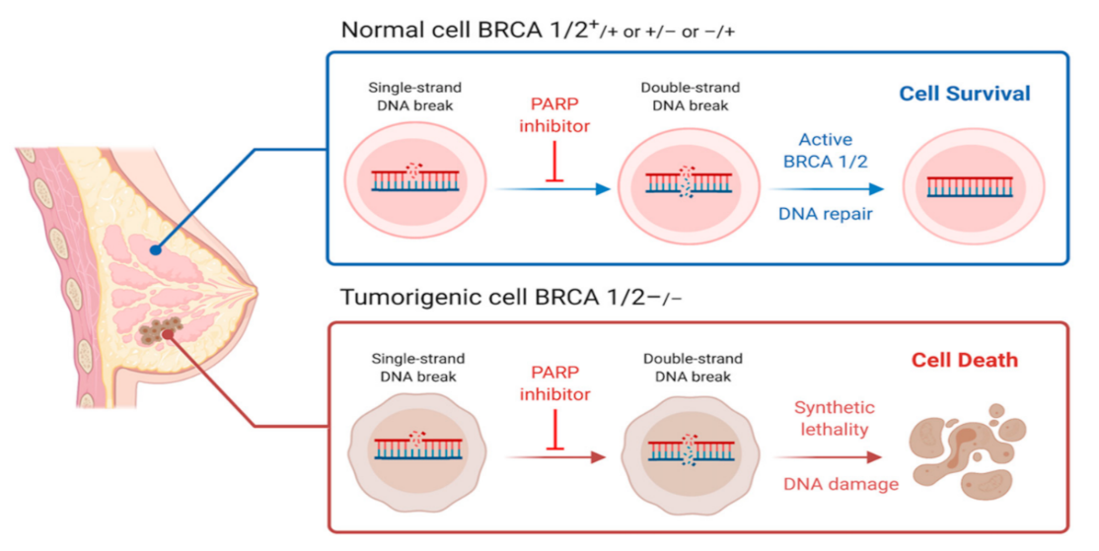

In the case of Patient 1, which express *BRCA1*, protein (ubiquitin) degradation therapy is recommended. Specifically, studies have shown that Cathepsine S (CTSS) inhibition regulates and restores BRCA protein stability (Kim et al., 2019; 문길임, 2021). However, the exact type of ubiquitin inhibitor should be decided after further testing at protein level, due to the excistence of two degradation pathways (proteasomal and lysosomal proteolysis) (Liao et al., 2021; Lin et al., 2022; Ming et al., 2023). In addition, it is recommended to be combined with platinum-based drugs, such as cisplatin, for regulated period of time and low dose (Belmonte-Fernández et al., 2023). This combination approach is proven effective with AT-406 inhibitor and carboplatin (platinum-based drug) in patients with ovarian cancer (Brunckhorst et al., 2012). Combination therapy aims to address mechanisms of resistance to platinum drugs, potentially improving treatment outcomes (Kelland, 2007). Furthermore, platinum-based drugs could be combined with nanoparticle-based delivery system to overcome again the cancer drug resistance issue (Kankala et al., 2020; Li & Lin, 2023; Xie et al., 2021). Another combination therapy option could be immunotherapy (checkpoint inhibitors or CAR-T cell therapy), chemotherapy, and again nanoparticle-based delivery system (Lei et al., 2020).

Multiple studies have shown that cancer in younger women (under 40) is much more aggressive than this in older patients (Beadle et al., 2011; Ribnikar et al., 2015). Therefore, in this context, cancer is very different and should be approached differently. Furthermore, comorbidity and age impact the treatment decisions in older breast cancer patients (over 75) (Hurria et al., 2003). Overall, PARPi have not shown any differences in their efficacy and toxicity by age (Dockery et al., 2017; Liposits et al., 2019). However, optimal breast cancer treatment decisions in older individuals are advised to be made through multidisciplinary discussions, ideally incorporating geriatric assessments, to enhance overall outcomes (de Boer et al., 2020; Markopoulos & van de Water, 2012).

**References**

Añez-Lingerfelt, M., Fox, G. E., & Willson, R. C. (2009). Reduction of DNA contamination in RNA samples for reverse transcription-polymerase chain reaction using selective precipitation by compaction agents. *Anal Biochem*, *384*(1), 79-85. <https://doi.org/10.1016/j.ab.2008.09.009>

Beadle, B. M., Woodward, W. A., & Buchholz, T. A. (2011). The impact of age on outcome in early-stage breast cancer. Seminars in radiation oncology,

Belmonte-Fernández, A., Herrero-Ruíz, J., Galindo-Moreno, M., Limón-Mortés, M. C., Mora-Santos, M., Sáez, C., Japón, M., Tortolero, M., & Romero, F. (2023). Cisplatin-induced cell death increases the degradation of the MRE11-RAD50-NBS1 complex through the autophagy/lysosomal pathway. *Cell Death Differ*, *30*(2), 488-499. <https://doi.org/10.1038/s41418-022-01100-1>

Birgisdottir, V., Stefansson, O. A., Bodvarsdottir, S. K., Hilmarsdottir, H., Jonasson, J. G., & Eyfjord, J. E. (2006). Epigenetic silencing and deletion of the BRCA1 gene in sporadic breast cancer. *Breast cancer research*, *8*, 1-10.

Blecua, P., Martinez‐Verbo, L., & Esteller, M. (2020). The DNA methylation landscape of hematological malignancies: An update. *Molecular Oncology*, *14*(8), 1616-1639.

Brunckhorst, M. K., Lerner, D., Wang, S., & Yu, Q. (2012). AT-406, an orally active antagonist of multiple inhibitor of apoptosis proteins, inhibits progression of human ovarian cancer. *Cancer Biol Ther*, *13*(9), 804-811. <https://doi.org/10.4161/cbt.20563>

Burguin, A., Diorio, C., & Durocher, F. (2021). Breast Cancer Treatments: Updates and New Challenges. *J Pers Med*, *11*(8). <https://doi.org/10.3390/jpm11080808>

Bustin, S. (2002). INVITED REVIEW Quantification of mRNA using real-time reverse transcription PCR (RT-PCR): trends and problems. *Journal of molecular endocrinology*, *29*, 23-39.

Carvalho, M. A., Couch, F. J., & Monteiro, A. N. (2007). Functional assays for BRCA1 and BRCA2. *The international journal of biochemistry & cell biology*, *39*(2), 298-310.

Catteau, A., & Morris, J. R. (2002). BRCA1 methylation: a significant role in tumour development? Seminars in cancer biology,

Copois, V., Bibeau, F., Bascoul-Mollevi, C., Salvetat, N., Chalbos, P., Bareil, C., Candeil, L., Fraslon, C., Conseiller, E., & Granci, V. (2007). Impact of RNA degradation on gene expression profiles: assessment of different methods to reliably determine RNA quality. *Journal of biotechnology*, *127*(4), 549-559.

Costa, J. L., Sousa, S., Justino, A., Kay, T., Fernandes, S., Cirnes, L., Schmitt, F., & Machado, J. C. (2013). Nonoptical massive parallel DNA sequencing of BRCA1 and BRCA2 genes in a diagnostic setting. *Human mutation*, *34*(4), 629-635.

Crowther, J. R. (2008). *ELISA: theory and practice* (Vol. 42). Springer Science & Business Media.

de Boer, A. Z., van de Water, W., Bastiaannet, E., de Glas, N. A., Kiderlen, M., Portielje, J. E., & Extermann, M. (2020). Early stage breast cancer treatment and outcome of older patients treated in an oncogeriatric care and a standard care setting: an international comparison. *Breast Cancer Research and Treatment*, *184*, 519-526.

Dias, M. P., Moser, S. C., Ganesan, S., & Jonkers, J. (2021). Understanding and overcoming resistance to PARP inhibitors in cancer therapy. *Nature reviews Clinical oncology*, *18*(12), 773-791.

Dockery, L. E., Tew, W. P., Ding, K., & Moore, K. N. (2017). Tolerance and toxicity of the PARP inhibitor olaparib in older women with epithelial ovarian cancer. *Gynecologic oncology*, *147*(3), 509-513.

Duraiyan, J., Govindarajan, R., Kaliyappan, K., & Palanisamy, M. (2012). Applications of immunohistochemistry. *Journal of pharmacy & bioallied sciences*, *4*(Suppl 2), S307.

Dwiyitno, D., Hoffman, S., Parmentier, K., & Keer, C. (2018). Method comparison of DNA isolation and quantification for fish and seafood authenticity determination. *Squalen Bulletin of Marine and Fisheries Postharvest and Biotechnology*, *13*(3), 115-124.

Fleige, S., & Pfaffl, M. W. (2006). RNA integrity and the effect on the real-time qRT-PCR performance. *Molecular aspects of medicine*, *27*(2-3), 126-139.

Galizia, E., Giorgetti, G., Piccinini, G., Santinelli, A., Loretelli, C., Bianchi, F., Gagliardini, D., Carbonari, G., Pisa, E., & Belvederesi, L. (2010). BRCA1 expression in triple negative sporadic breast cancers. *Anal Quant Cytol Histol*, *32*(1), 24-29.

Garcia, A. I., Buisson, M., Bertrand, P., Rimokh, R., Rouleau, E., Lopez, B. S., Lidereau, R., Mikaélian, I., & Mazoyer, S. (2011). Down-regulation of BRCA1 expression by miR-146a and miR-146b-5p in triple negative sporadic breast cancers. *EMBO Mol Med*, *3*(5), 279-290. <https://doi.org/10.1002/emmm.201100136>

Godet, I., & Gilkes, D. M. (2017). BRCA1 and BRCA2 mutations and treatment strategies for breast cancer. *Integr Cancer Sci Ther*, *4*(1). <https://doi.org/10.15761/icst.1000228>

Guo, Y., Xiao, P., Lei, S., Deng, F., Xiao, G. G., Liu, Y., Chen, X., Li, L., Wu, S., Chen, Y., Jiang, H., Tan, L., Xie, J., Zhu, X., Liang, S., & Deng, H. (2008). How is mRNA expression predictive for protein expression? A correlation study on human circulating monocytes. *Acta Biochim Biophys Sin (Shanghai)*, *40*(5), 426-436. <https://doi.org/10.1111/j.1745-7270.2008.00418.x>

Gygi, S. P., Rochon, Y., Franza, B. R., & Aebersold, R. (1999). Correlation between protein and mRNA abundance in yeast. *Molecular and cellular biology*.

Hurria, A., Leung, D., Trainor, K., Borgen, P., Norton, L., & Hudis, C. (2003). Factors influencing treatment patterns of breast cancer patients age 75 and older. *Critical reviews in oncology/hematology*, *46*(2), 121-126.

Kankala, R. K., Liu, C.-G., Yang, D.-Y., Wang, S.-B., & Chen, A.-Z. (2020). Ultrasmall platinum nanoparticles enable deep tumor penetration and synergistic therapeutic abilities through free radical species-assisted catalysis to combat cancer multidrug resistance. *Chemical Engineering Journal*, *383*, 123138.

Kelland, L. (2007). The resurgence of platinum-based cancer chemotherapy. *Nature Reviews Cancer*, *7*(8), 573-584.

Keung, M. Y. T., Wu, Y., & Vadgama, J. V. (2019). PARP inhibitors as a therapeutic agent for homologous recombination deficiency in breast cancers. *Journal of clinical medicine*, *8*(4), 435.

Kim, M. C., Choi, J. E., Lee, S. J., & Bae, Y. K. (2016). Coexistent loss of the expressions of BRCA1 and p53 predicts poor prognosis in triple-negative breast cancer. *Annals of surgical oncology*, *23*, 3524-3530.

Kim, S., Jin, H., Seo, H.-R., Lee, H. J., & Lee, Y.-S. (2019). Regulating BRCA1 protein stability by cathepsin S-mediated ubiquitin degradation. *Cell Death & Differentiation*, *26*(5), 812-825.

Lee, M. S., Green, R., Marsillac, S. M., Coquelle, N., Williams, R. S., Yeung, T., Foo, D., Hau, D. D., Hui, B., & Monteiro, A. N. (2010). Comprehensive analysis of missense variations in the BRCT domain of BRCA1 by structural and functional assays. *Cancer research*, *70*(12), 4880-4890.

Lee, W.-Y. (2002). Frequent loss of BRCA1 nuclear expression in young women with breast cancer: an immunohistochemical study from an area of low incidence but early onset. *Applied Immunohistochemistry & Molecular Morphology*, *10*(4), 310-315.

Lei, J., Wang, H., Zhu, D., Wan, Y., & Yin, L. (2020). Combined effects of avasimibe immunotherapy, doxorubicin chemotherapy, and metal-organic frameworks nanoparticles on breast cancer. *J Cell Physiol*, *235*(5), 4814-4823. <https://doi.org/10.1002/jcp.29358>

Li, H., Liu, Z.-Y., Wu, N., Chen, Y.-C., Cheng, Q., & Wang, J. (2020). PARP inhibitor resistance: the underlying mechanisms and clinical implications. *Molecular cancer*, *19*, 1-16.

Li, Q., Wei, W., Jiang, Y., Yang, H., & Liu, J. (2015). Promoter methylation and expression changes of BRCA1 in cancerous tissues of patients with sporadic breast cancer. *Oncology letters*, *9*(4), 1807-1813.

Li, Y., & Lin, W. (2023). Platinum-based combination nanomedicines for cancer therapy. *Current Opinion in Chemical Biology*, *74*, 102290.

Liao, C., Yu, L., Pang, Z., Deng, H., Liao, X., Li, S., Cheng, J., Qi, M., Chen, G., & Huang, L. (2021). WWP1 targeting MUC1 for ubiquitin-mediated lysosomal degradation to suppress carcinogenesis. *Signal transduction and targeted therapy*, *6*(1), 297.

Lin, C.-Y., Yu, C.-J., Liu, C.-Y., Chao, T.-C., Huang, C.-C., Tseng, L.-M., & Lai, J.-I. (2022). CDK4/6 inhibitors downregulate the ubiquitin-conjugating enzymes UBE2C/S/T involved in the ubiquitin–proteasome pathway in ER+ breast cancer. *Clinical and Translational Oncology*, *24*(11), 2120-2135.

Liposits, G., Loh, K. P., Soto-Perez-de-Celis, E., Dumas, L., Battisti, N. M. L., Kadambi, S., Baldini, C., Banerjee, S., & Lichtman, S. M. (2019). PARP inhibitors in older patients with ovarian and breast cancer: Young International Society of Geriatric Oncology review paper. *Journal of geriatric oncology*, *10*(2), 337-345.

Lips, E., Mulder, L., Oonk, A., Van Der Kolk, L., Hogervorst, F., Imholz, A., Wesseling, J., Rodenhuis, S., & Nederlof, P. (2013). Triple-negative breast cancer: BRCAness and concordance of clinical features with BRCA1-mutation carriers. *British journal of cancer*, *108*(10), 2172-2177.

Liu, L.-L., Zhao, H., Ma, T.-F., Ge, F., Chen, C.-S., & Zhang, Y.-P. (2015). Identification of valid reference genes for the normalization of RT-qPCR expression studies in human breast cancer cell lines treated with and without transient transfection. *PloS one*, *10*(1), e0117058.

Lyng, M. B., Lænkholm, A.-V., Pallisgaard, N., & Ditzel, H. J. (2008). Identification of genes for normalization of real-time RT-PCR data in breast carcinomas. *BMC cancer*, *8*, 1-11.

Markopoulos, C., & van de Water, W. (2012). Older patients with breast cancer: is there bias in the treatment they receive? *Therapeutic advances in medical oncology*, *4*(6), 321-327.

Mateo, J., Lord, C., Serra, V., Tutt, A., Balmaña, J., Castroviejo-Bermejo, M., Cruz, C., Oaknin, A., Kaye, S., & De Bono, J. (2019). A decade of clinical development of PARP inhibitors in perspective. *Annals of Oncology*, *30*(9), 1437-1447.

Ming, H., Li, B., Jiang, J., Qin, S., Nice, E. C., He, W., Lang, T., & Huang, C. (2023). Protein degradation: expanding the toolbox to restrain cancer drug resistance. *Journal of Hematology & Oncology*, *16*(1), 6.

Mohsen, M. G., Ji, D., & Kool, E. T. (2019). Polymerase synthesis of four-base DNA from two stable dimeric nucleotides. *Nucleic Acids Res*, *47*(18), 9495-9501. <https://doi.org/10.1093/nar/gkz741>

Mylavarapu, S., Das, A., & Roy, M. (2018). Role of BRCA Mutations in the Modulation of Response to Platinum Therapy [Review]. *Frontiers in Oncology*, *8*. <https://doi.org/10.3389/fonc.2018.00016>

Narod, S. A., & Salmena, L. (2011). BRCA1 and BRCA2 mutations and breast cancer. *Discov Med*, *12*(66), 445-453.

Neiger, H. E., Siegler, E. L., & Shi, Y. (2021). Breast cancer predisposition genes and synthetic lethality. *International Journal of Molecular Sciences*, *22*(11), 5614.

O'Neil, N. J., Bailey, M. L., & Hieter, P. (2017). Synthetic lethality and cancer. *Nature Reviews Genetics*, *18*(10), 613-623.

Peters, I., Helps, C., Hall, E., & Day, M. (2004). Real-time RT-PCR: considerations for efficient and sensitive assay design. *Journal of immunological methods*, *286*(1-2), 203-217.

Press, J. Z., De Luca, A., Boyd, N., Young, S., Troussard, A., Ridge, Y., Kaurah, P., Kalloger, S. E., Blood, K. A., & Smith, M. (2008). Ovarian carcinomas with genetic and epigenetic BRCA1 loss have distinct molecular abnormalities. *BMC cancer*, *8*(1), 1-12.

Ribnikar, D., Ribeiro, J., Pinto, D., Sousa, B., Pinto, A., Gomes, E., Moser, E., Cardoso, M., & Cardoso, F. (2015). Breast cancer under age 40: a different approach. *Current treatment options in oncology*, *16*, 1-24.

Rice, J. C., Massey-Brown, K. S., & Futscher, B. W. (1998). Aberrant methylation of the BRCA1 CpG island promoter is associated with decreased BRCA1 mRNA in sporadic breast cancer cells. *Oncogene*, *17*(14), 1807-1812.

Rice, J. C., Ozcelik, H., Maxeiner, P., Andrulis, I., & Futscher, B. W. (2000). Methylation of the BRCA1 promoter is associated with decreased BRCA1 mRNA levels in clinical breast cancer specimens. *Carcinogenesis*, *21*(9), 1761-1765.

Rottenberg, S., Jaspers, J. E., Kersbergen, A., van der Burg, E., Nygren, A. O., Zander, S. A., Derksen, P. W., de Bruin, M., Zevenhoven, J., & Lau, A. (2008). High sensitivity of BRCA1-deficient mammary tumors to the PARP inhibitor AZD2281 alone and in combination with platinum drugs. *Proceedings of the National Academy of Sciences*, *105*(44), 17079-17084.

Russell, P. A., Pharoah, P. D., De Foy, K., Ramus, S. J., Symmonds, I., Wilson, A., Scott, I., Ponder, B. A., & Gayther, S. A. (2000). Frequent loss of BRCA1 mRNA and protein expression in sporadic ovarian cancers. *International journal of cancer*, *87*(3), 317-321.

Silver, D. P., & Livingston, D. M. (2012). Mechanisms of BRCA1 tumor suppression. *Cancer discovery*, *2*(8), 679-684.

Sun, W., Wu, Y., Ma, F., Fan, J., & Qiao, Y. (2023). Efficacy of PARP Inhibitor, Platinum, and Immunotherapy in BRCA-Mutated HER2-Negative Breast Cancer Patients: A Systematic Review and Network Meta-Analysis. *Journal of clinical medicine*, *12*(4), 1588.

Takaoka, M., & Miki, Y. (2018). BRCA1 gene: function and deficiency. *International journal of clinical oncology*, *23*, 36-44.

Teixeira, L. A., & Dos Reis, F. J. C. (2020). Immunohistochemistry for the detection of BRCA1 and BRCA2 proteins in patients with ovarian cancer: a systematic review. *Journal of Clinical Pathology*, *73*(4), 191-196.

Thompson, M. E., Jensen, R. A., Obermiller, P. S., Page, D. L., & Holt, J. T. (1995). Decreased expression of BRCA1 accelerates growth and is often present during sporadic breast cancer progression. *Nature genetics*, *9*(4), 444-450.

Wagner, E. M. (2013). Monitoring gene expression: quantitative real-time rt-PCR. *Lipoproteins and Cardiovascular Disease: Methods and Protocols*, 19-45.

Wang, H., Yang, B., Geng, T., Li, B., Dai, P., & Chen, C. (2015). Tissue-specific selection of optimal reference genes for expression analysis of anti-cancer drug-related genes in tumor samples using quantitative real-time RT-PCR. *Experimental and molecular pathology*, *98*(3), 375-381.

Wang, X., Shi, Y., Huang, D., & Guan, X. (2018). Emerging therapeutic modalities of PARP inhibitors in breast cancer. *Cancer treatment reviews*, *68*, 62-68.

Wilkinson, L., & Gathani, T. (2022). Understanding breast cancer as a global health concern. *Br J Radiol*, *95*(1130), 20211033. <https://doi.org/10.1259/bjr.20211033>

Winter, S. L., Bosnoyan-Collins, L., Pinnaduwage, D., & Andrulis, I. L. (2007). The interaction of PP1 with BRCA1 and analysis of their expression in breast tumors. *BMC cancer*, *7*, 85. <https://doi.org/10.1186/1471-2407-7-85>

Xie, P., Wang, Y., Wei, D., Zhang, L., Zhang, B., Xiao, H., Song, H., & Mao, X. (2021). Nanoparticle-based drug delivery systems with platinum drugs for overcoming cancer drug resistance. *Journal of Materials Chemistry B*, *9*(26), 5173-5194.

Yan, T., Cui, H., Zhou, Y., Yang, B., Kong, P., Zhang, Y., Liu, Y., Wang, B., Cheng, Y., Li, J., Guo, S., Xu, E., Liu, H., Cheng, C., Zhang, L., Chen, L., Zhuang, X., Qian, Y., Yang, J., . . . Cui, Y. (2019). Multi-region sequencing unveils novel actionable targets and spatial heterogeneity in esophageal squamous cell carcinoma. *Nat Commun*, *10*(1), 1670. <https://doi.org/10.1038/s41467-019-09255-1>

Yoshida, K., & Miki, Y. (2004). Role of BRCA1 and BRCA2 as regulators of DNA repair, transcription, and cell cycle in response to DNA damage. *Cancer science*, *95*(11), 866-871.

Zhu, Y., Wu, J., Zhang, C., Sun, S., Zhang, J., Liu, W., Huang, J., & Zhang, Z. (2016). BRCA mutations and survival in breast cancer: an updated systematic review and meta-analysis. *Oncotarget*, *7*(43), 70113-70127. <https://doi.org/10.18632/oncotarget.12158>

문길임. (2021). Part I. Decreased expression of FBXW7 in drug resistant cancer cells inhibits ubiquitin degradation of HSF1 and promotes transcriptional activation of MDR1 Part II. Cathepsin S regulates BRCA1 protein stability and induces radioresistance.